|  |  |
| --- | --- |
| **DATE** | 20 OCTOBER 2022 |
| **TEAM ID** | PNT2022TMID28519 |
| **PROJECT NAME** | PROJECT – News Tracker |
| **MAXIMUM MARKS** | 8 MARKS |

**PROJECT PLANNING PHASE**

**PROJECT PLANNING TEMPLATE (PRODUCT BACKLOG, SPRINT PLANNING, STORIES, STORY POINTS)**

**Product Backlog, Sprint Schedule and Estimation (4 Marks)**

Use the below template to create product backlog and sprint schedule

|  |  |  |  |  |  |  |
| --- | --- | --- | --- | --- | --- | --- |
| **Sprint** | **Functional Requirement (EPIC)** | **User Story Number** | **User Story / Task** | **Story Points** | **Priority** | **Team Members** |
| **Sprint - 1** | Registration | USN - 1 | As a Number, I can Register for the application by entering my password.as a User, I will receive confirmation email once I have Registered for the application | 10 | HIGH | MONISH V, MANIGANDAN R |
| **Sprint - 1** | Login | USN - 2 | As a user, I will receive confirmation email once I have registered for the application | 5 | HIGH | SAIRAM G, ROHITH B |
| **Sprint - 1** | Email Verification | USN - 3 | As A User I Can Verify My Email Using the Link Sent to My Mail id | 5 | HIGH | MONISH V, SAIRAM G |
| **Sprint - 2** | API Fetch | USN - 4 | Fetch News from Rapid API at regular interval | 10 | HIGH | MANIGANDAN R, ROHITH B |
| **Sprint - 2** | REST Endpoints for Backend | USN - 5 | Creating endpoints at the backend in order to interact with frontend | 10 | MEDIUM | MANIGANDAN R, SAIRAM G |
| **Sprint - 3** | Designing Frontend | USN - 6 | Create a minimalisting design in figma to create frontend | 2 | MEDIUM | MONISH V, ROHITH B |
| **Sprint - 3** | Creating Frontend | USN - 7 | Create the frontend webpage using the design | 10 | LOW | SAIRAM G, ROHITH B |
| **Sprint - 3** | Connect Frontend and backend | USN - 8 | Connect the frontend and backend and complete the application | 8 | HIGH | MONISH V, MANIGANDAN R |
| **Sprint - 4** | Testing | USN - 9 | Testing the application before final release | 10 | HIGH | SAIRAM G, MONISH V |
| **Sprint - 4** | Deployment | USN - 10 | Deployment of the application | 10 | HIGH | MANIGANDAN R, ROHITH B |

| **Sprint** | **Total Story Points** | **Duration** | **Sprint Start Date** | **Sprint End Date (Planned)** | **Story Points Completed (as on Planned End Date)** | **Sprint Release Date (Actual)** |
| --- | --- | --- | --- | --- | --- | --- |
| **Sprint-1** | 20 | 6 Days | 24 Oct 2022 | 29 Oct 2022 | 20 | 29 Oct 2022 |
| **Sprint-2** | 20 | 6 Days | 31 Oct 2022 | 05 Nov 2022 | 20 | 05 Nov 2022 |
| **Sprint-3** | 20 | 6 Days | 07 Nov 2022 | 12 Nov 2022 | 20 | 12 Nov 2022 |
| **Sprint-4** | 20 | 6 Days | 14 Nov 2022 | 19 Nov 2022 | 20 | 19 Nov 2022 |

**Project Tracker, Velocity & Burndown Chart: (4 Marks)**

**Velocity:**

Imagine we have a 10-day sprint duration, and the velocity of the team is 20 (points per sprint). Let’s calculate the team’s average velocity (AV) per iteration unit (story points per day)

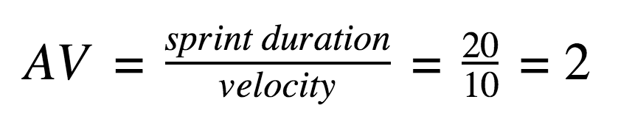

**Burndown Chart:**

A burn down chart is a graphical representation of work left to do versus time. It is often used in agile [software development](https://www.visual-paradigm.com/scrum/what-is-agile-software-development/) methodologies such as [Scrum](https://www.visual-paradigm.com/scrum/scrum-in-3-minutes/). However, burn down charts can be applied to any project containing measurable progress over time.